**MODULE:1(SDLC)**

1. **What is software? What is software engineering?**

**Software**…….. is a set of instructions, data, or programs used to operate a computer and execute specific tasks. In simpler terms, software tells a computer how to function. It’s a generic term used to refer to applications, scripts, and programs that run on devices such as PCs, mobile phones, tablets, and other smart devices. Software contrasts with hardware, which is the physical aspects of a computer that perform the work.

**Software engineering**…… is defined as a process of analysing user requirements and then designing, building, and testing software application which will satisfy those requirements.

**======================================================**

1. **Explain types of software**

there are different types of software based on their classification however, if we broadly classify the types of software in a computer, there are two major types as listed below:

**\*system software**

**\*application software**

**------SYSTEM SOFTWARE-----------------** System software helps the user, the computer or mobile device, and an application all work together seamlessly. This makes system software crucial to running any kind Think about when your laptop or phone has an update. This is system software in action: there is a tweak made to the system software that helps your computer or phone continue to work well and keep applications running. Apple’s iOS is an example of system software, as is Microsoft Windows. System software is always running in the background of your device, but it is never something you will use directly. In fact, the only time most people remember it’s there is when it is time for an update.

**-------------APPLICATION SOFTWERE----------------- An** application program (software application, or application, or app for short) is a computer program designed to carry out a specific task other than one relating to the operation of the computer itself,[1] typically to be used by end-users.[2] Word processors, media players, and accounting software are examples. The collective noun "application software" refers to all applications collectively.[3] The other principal classifications of software are system software, relating to the operation of the computer, and utility software ("utilities"). Applications may be bundled with the computer and its system software or published separately and may be coded as proprietary, open-source, or projects.[4] The term "app" usually refers to applications for mobile devices such as phones

**======================================================**

1. **What is SDLC? Explain each phase of SDLC**

SDLC, or Software Development Life Cycle, is a set of steps used to create software applications. These steps divide the development process into tasks that can then be assigned, completed, and measured.

Software Development Life Cycle is the application of standard business practices to building software applications. It’s typically divided into six to eight steps: Planning, Requirements, Design, Build, Document, Test,Deploy, Maintain. Some project managers will combine, split, or omit steps, depending on the project’s scope. These are the core components recommended for all software development projects. 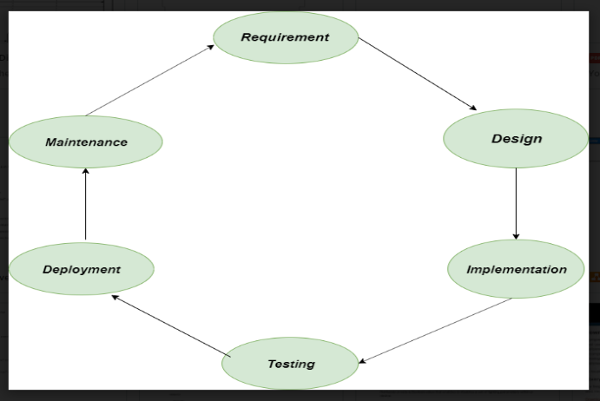

**1. Requirement:** In this phase, all the requirements are collected from the customer/client. They are provided in a document called Businessmen requirement specification (BRS) and System requirement specification (SRS). All the details are discussed with the customer/client in detail.

**2. Design:** It has two steps:

* **High-level design (HLD):** It gives the architecture of software products.
* **Low-level design (LLD):** It describes how each and every feature in the product should work and every component.

**3. Implementation:**

* This is the longest phase.
* This phase consists of Front end + Middleware + Back-end.
* **In front-end:**Development of coding is done even SEO settings are done.
* **In Middleware:** They connect both the front end and back end.
* **In the back-end:** A database is created.

**4. Testing:** Testing is carried out to verify the entire system. The aim of the tester is to find out the gaps and defects within the system and also to check whether the system is running according to the requirement of the customer/client.

**5. Deployment:** After successful testing, the product is delivered/deployed to the client, and even clients are trained on how to use the product.

**6. Maintenance:** Once the product has been delivered to the client a task of maintenance starts as when the client will come up with an error the issue should be fixed from time to time.

**======================================================**

1. **What is DFD? Create a DFD diagram on Flipkart**

A data flow diagram is a graphical view of how data is processed in a system in terms of input and output.  
The Data flow diagram (DFD) contains some symbol for drawing the data flow diagram.

Data flow diagram symbol

|  |  |
| --- | --- |
| **Symbol** | **Description** |
| [dfd symbol](https://meeraacademy.com/wp-content/uploads/2016/09/arro.jpg) | **Data Flow** – Data flow are pipelines through the packets of information flow. |
| [dfd process](https://meeraacademy.com/wp-content/uploads/2016/09/process.jpg) | **Process :**A Process or task performed by the system. |
| [dfd entry symbol](https://meeraacademy.com/wp-content/uploads/2016/09/Entity.jpg) | **Entity :**Entity are object of the system. A source or destination data of a system. |
| [dfd source symbol](https://meeraacademy.com/wp-content/uploads/2016/09/source.jpg) | **Data Store :** A place where data to be stored. |

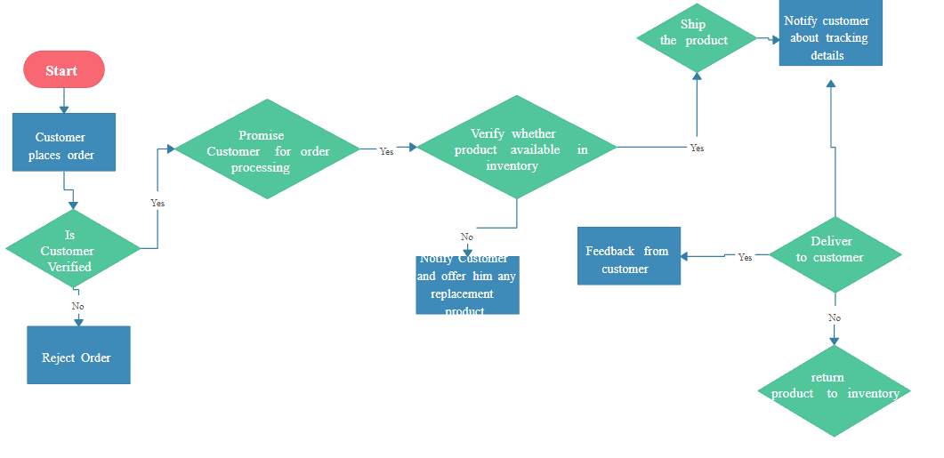

**======================================================**

1. **What is Flow chart? Create a Flowchart to make addition of two numbers**

**A flowchart**……is **a diagram that shows an overview of a program** . Flowcharts normally use standard symbols to represent the different types of instructions . These symbols are used to construct the flowchart and show the step-by-step solution to the problem. Flowcharts are sometimes known as flow diagrams.

Print sum

Declare variables no.1,no.2 and sum

Read no.1 and no.2

Add no.1,no.2 and assign value to sum

Sum=no.1 + no.2

**======================================================**

1. **What is Use of Diagram? Create a use-case on bill payment on pytm.**

Diagrams are graphic representations used to explain the relationships and connections between the parts it illustrates. There are many subcategories of the broader term 'diagram', which are distinguished by the elements they incorporate or their overall topic.

